PROJECT REPORT

Major Project on the topics:

1. Choose any dataset of your choice and apply a suitable CLASSIFIER/REGRESSOR .
2. Create any of the Image Processing Projects using Numpy and/or OpenCV.

Submitted by:

**NIVETHA SREE M**

IIIrd Year

Computer Science and Engineeering

Adhiyamaan College of Engineering, Hosur.

Date: 14-01-2023

Objective: Choose any dataset of your choice and apply a suitable CLASSIFIER/REGRESSOR .

Dataset: <https://www.kaggle.com/datasets/dhamur/airtel-prepaid>

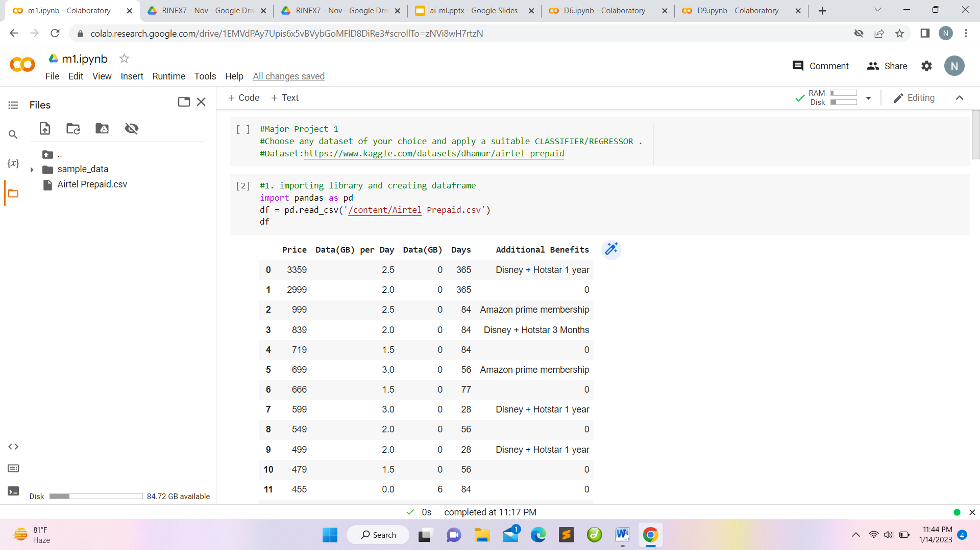

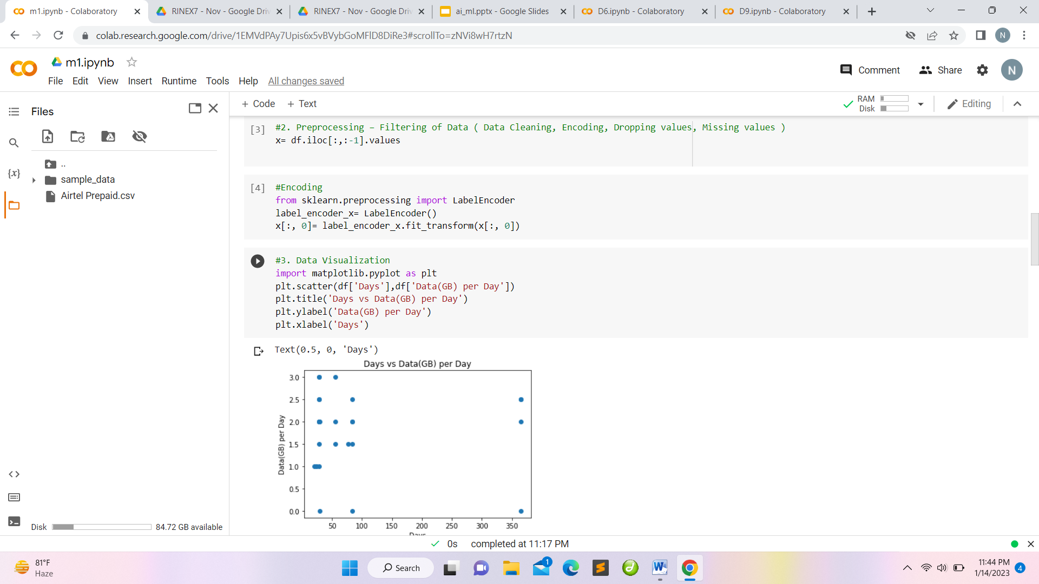

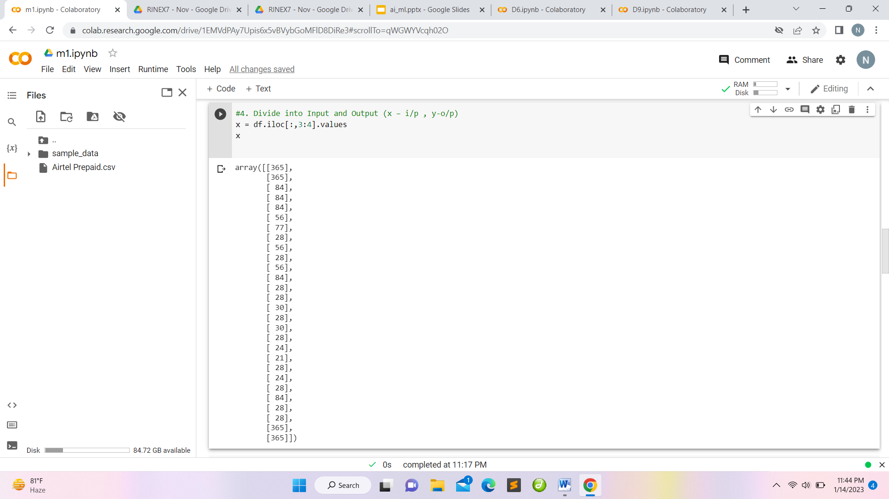

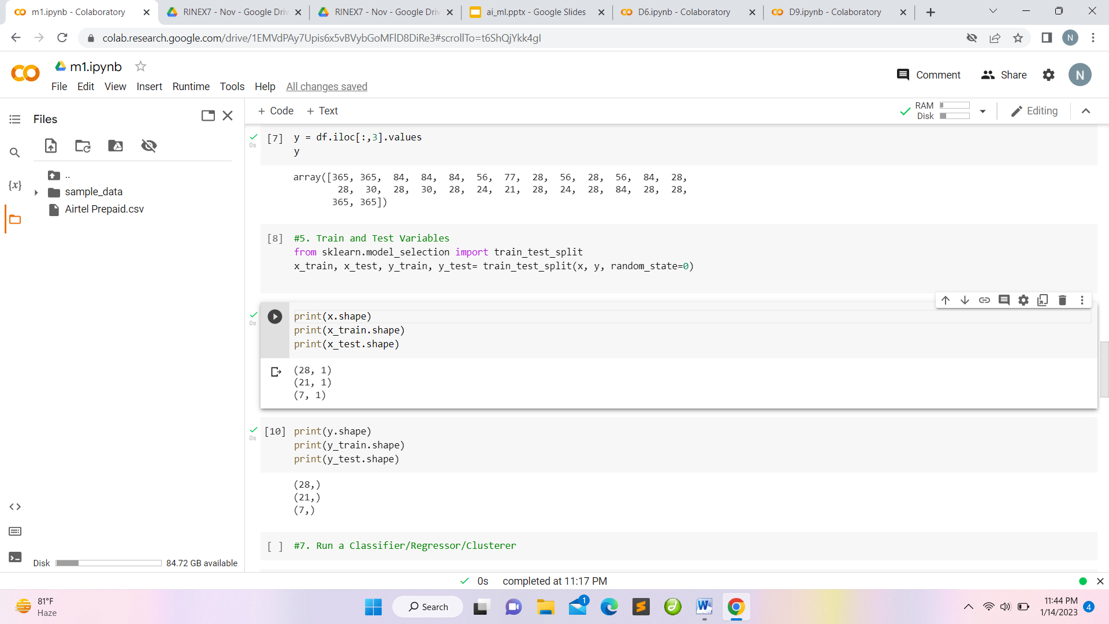

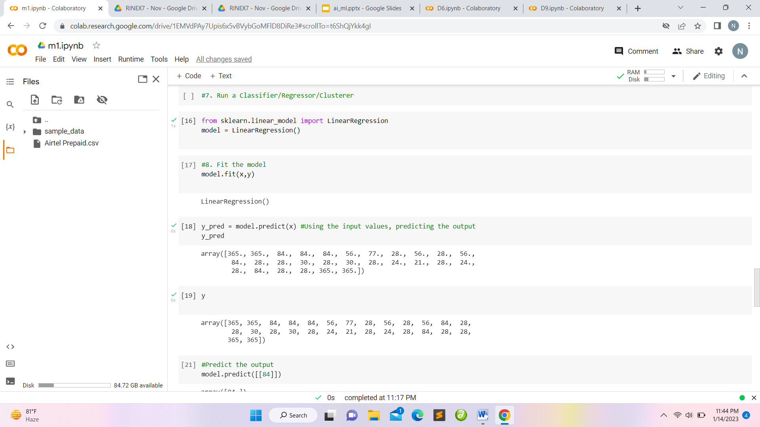

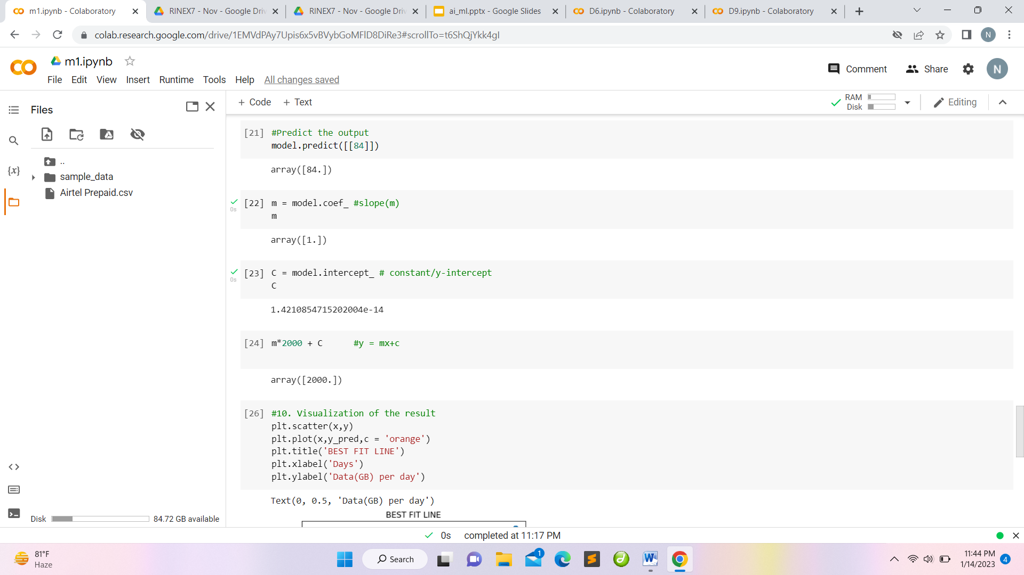

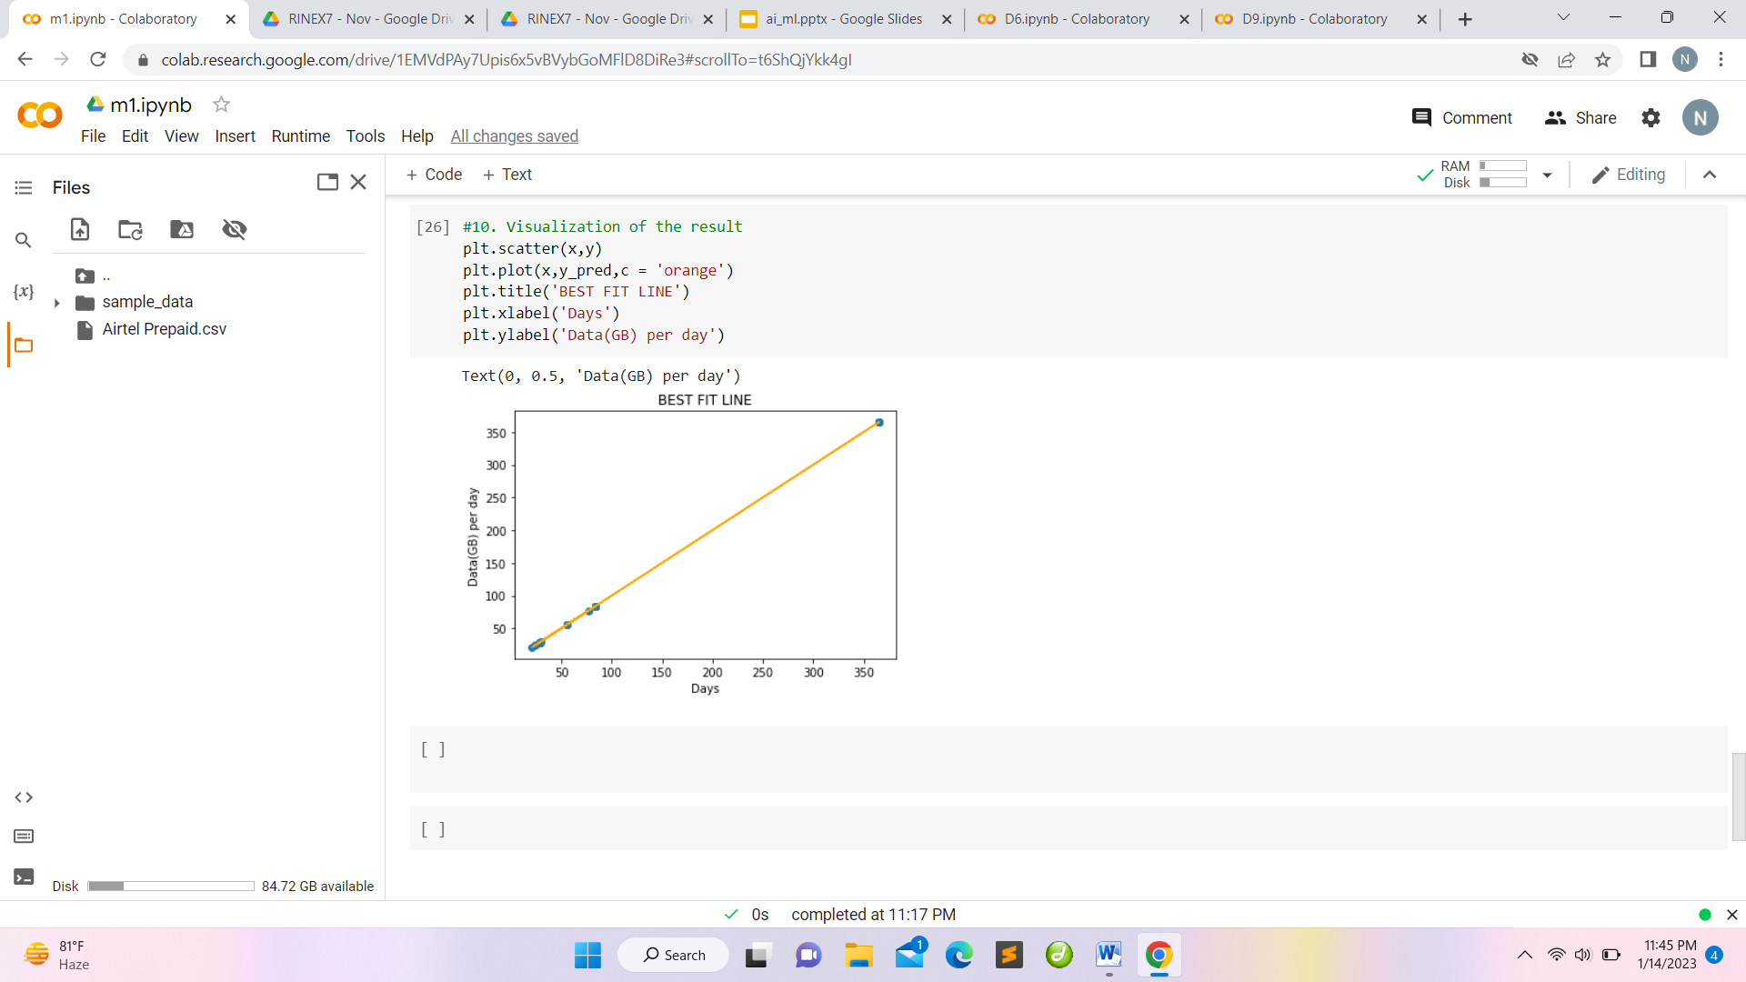

Objective: Create any of the Image Processing Projects using Numpy and/or OpenCV.

1. Changing Colorspace

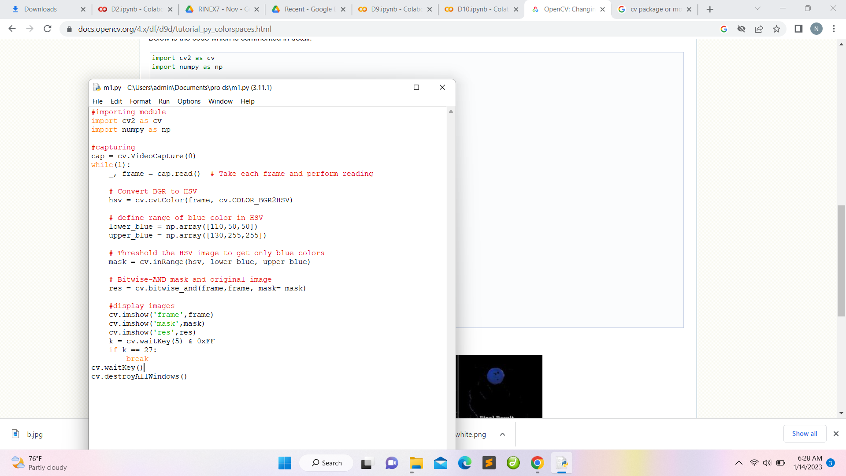

Output:

Original

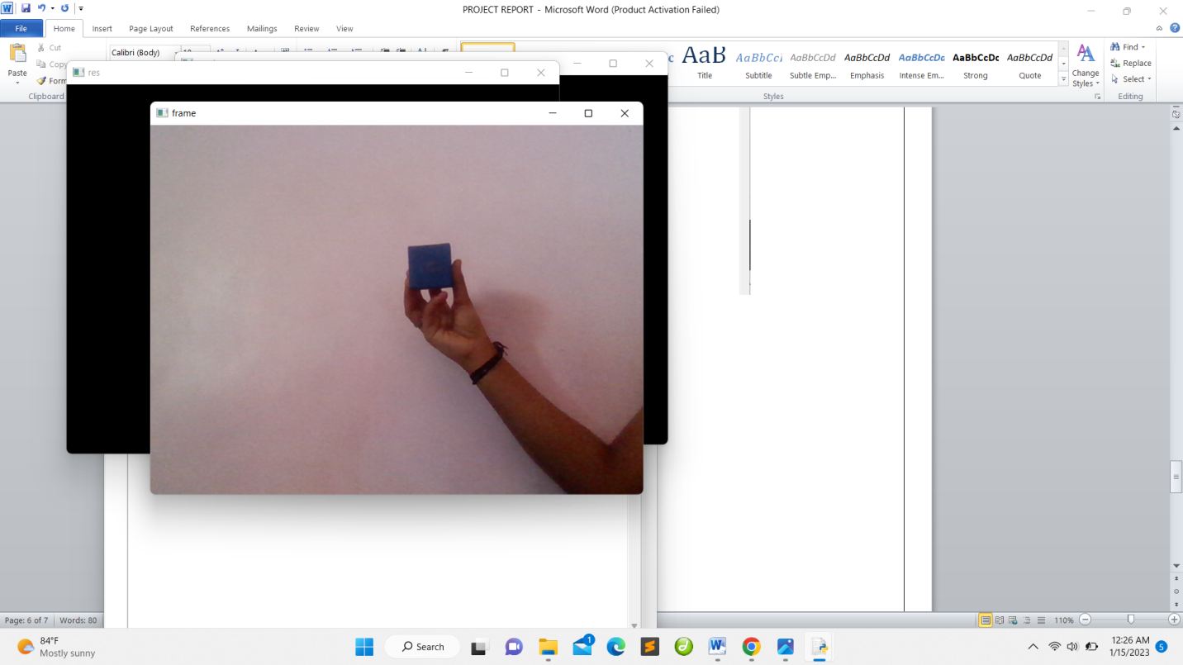

Threshold Bit-wise image

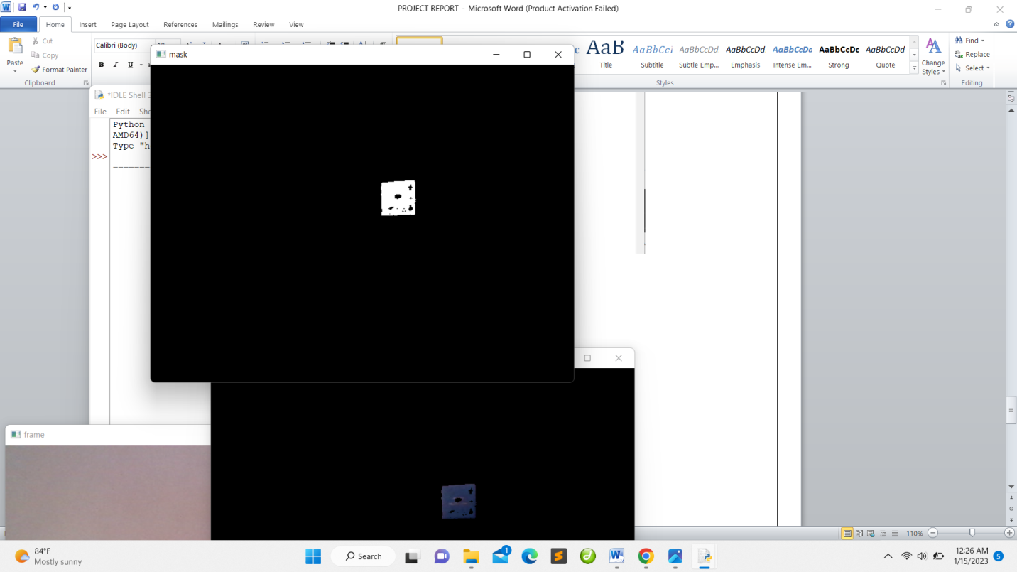 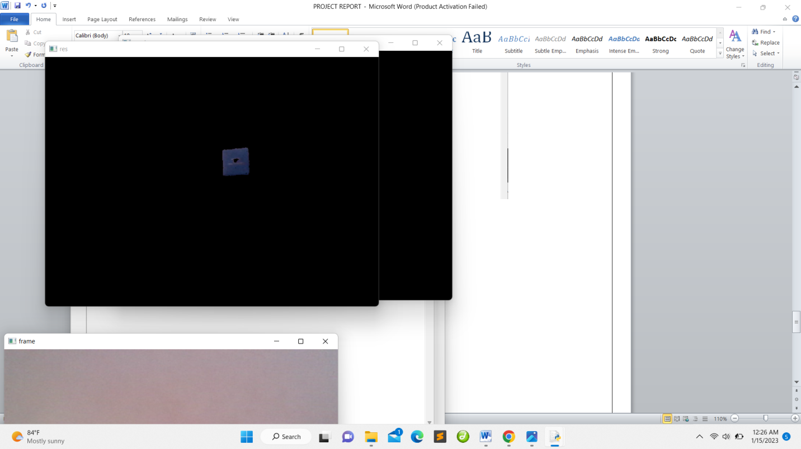

1. Bluring of the image

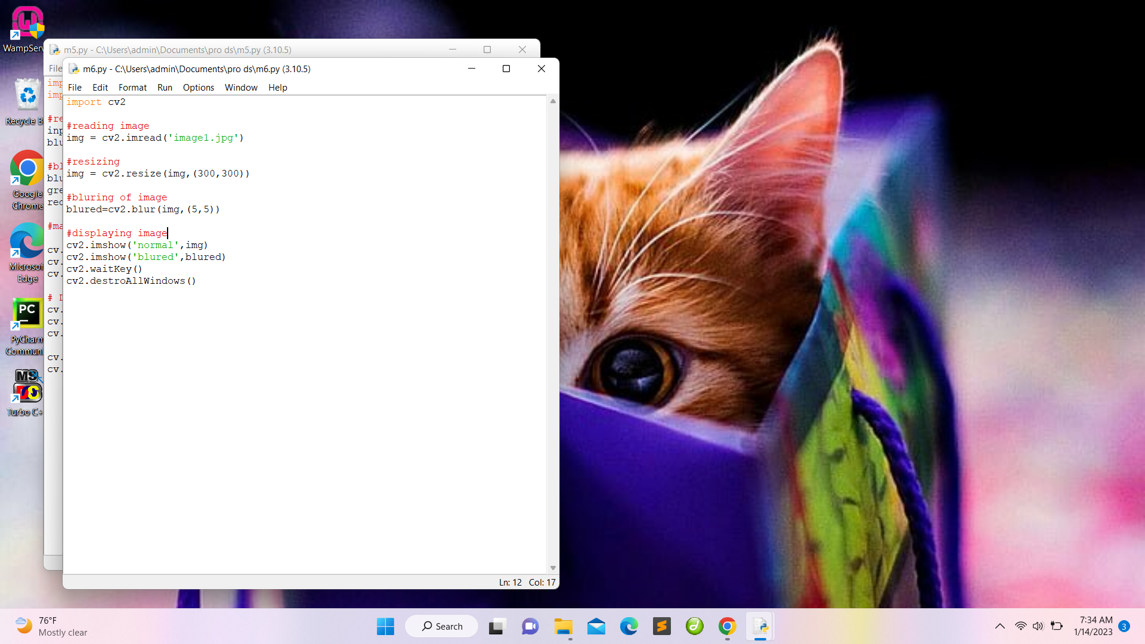

Output

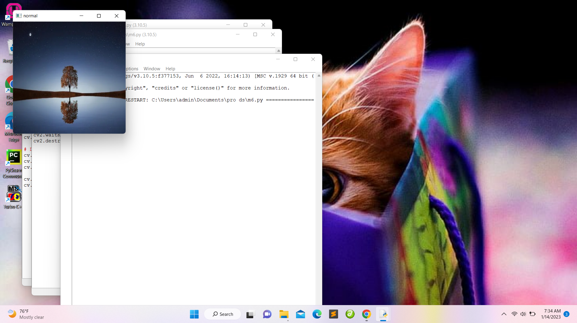 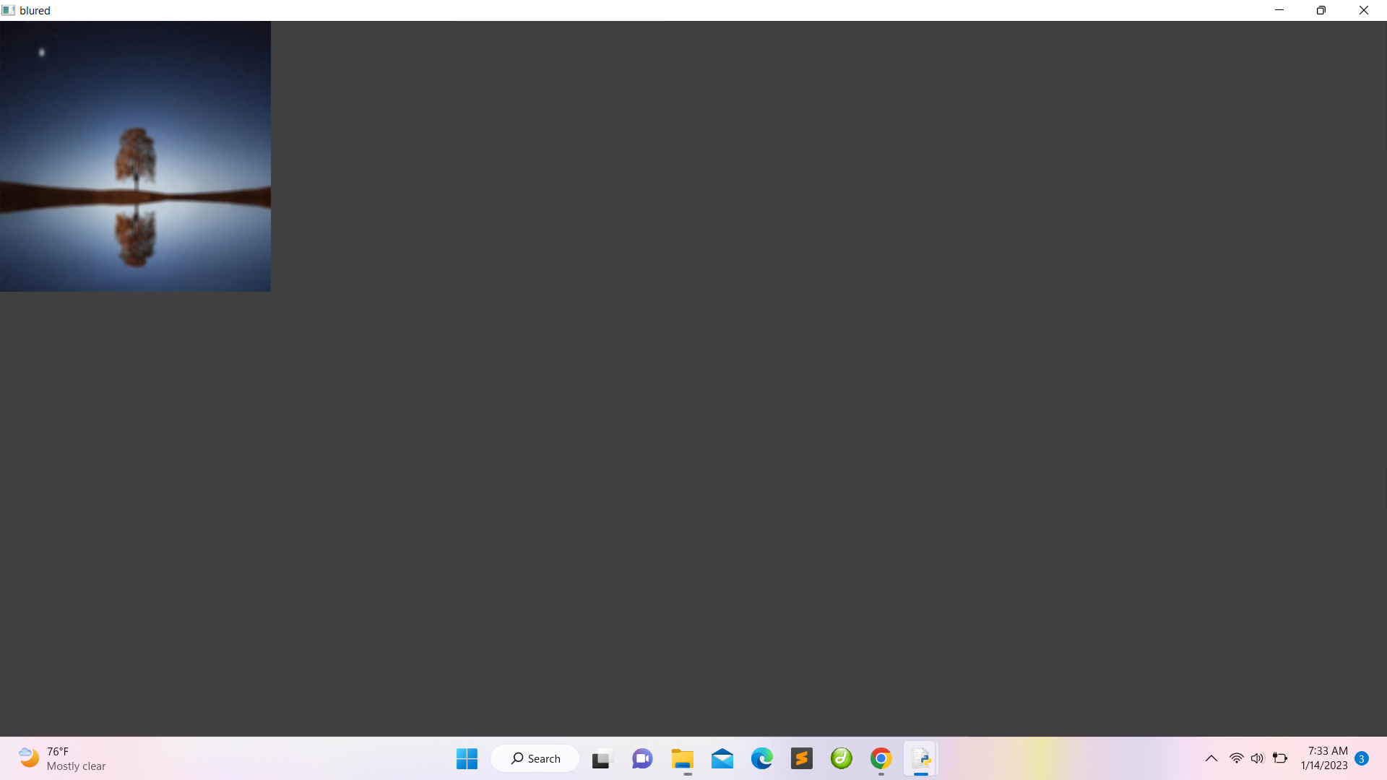

1. Hough Circle

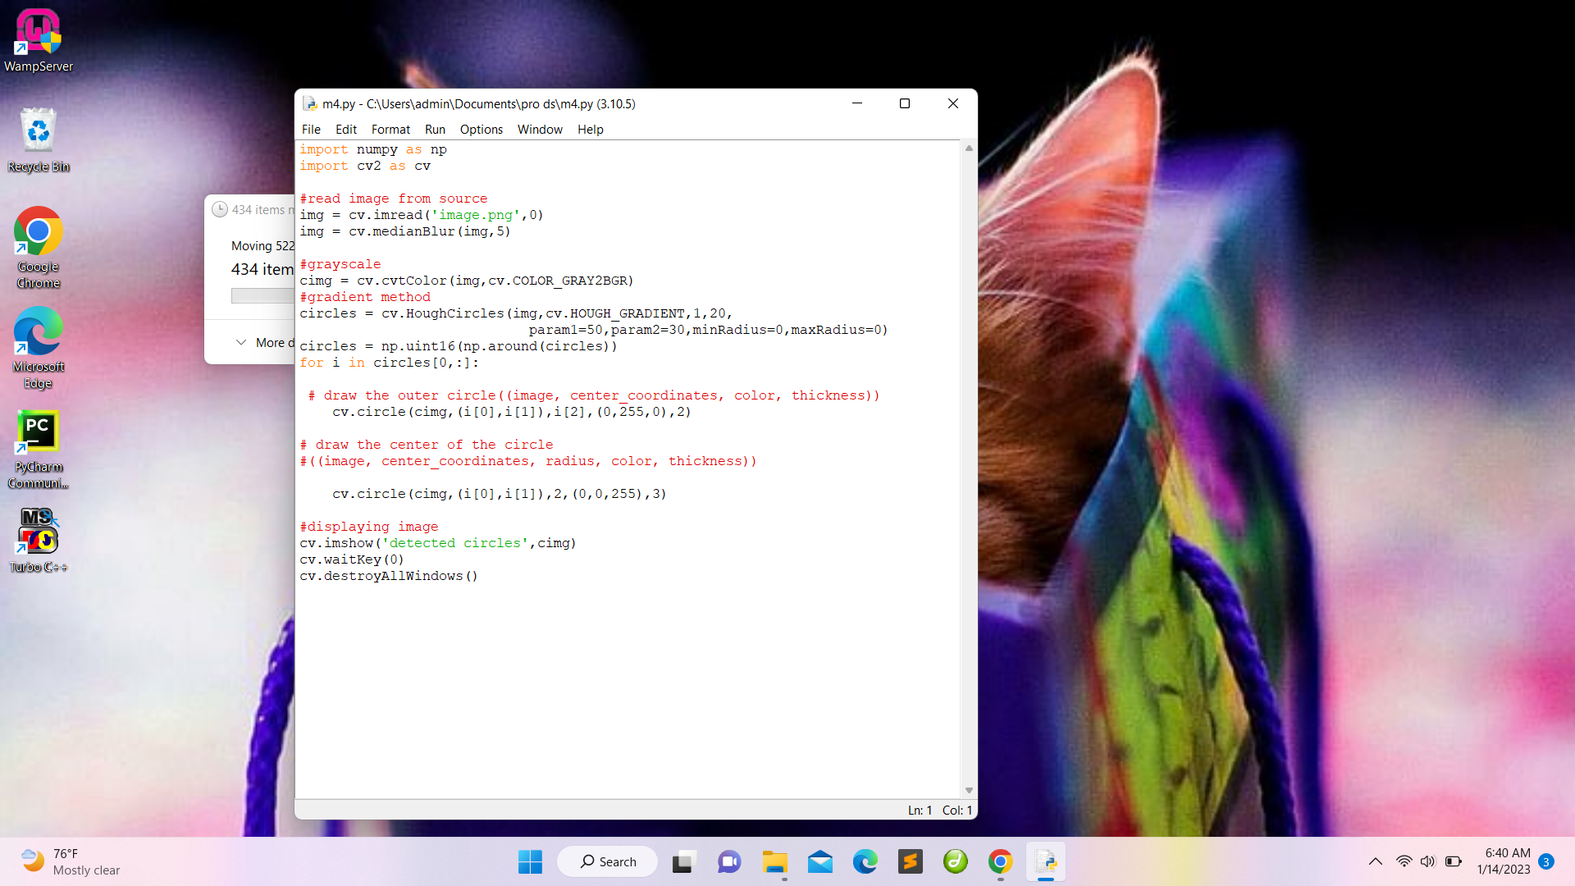

Output:

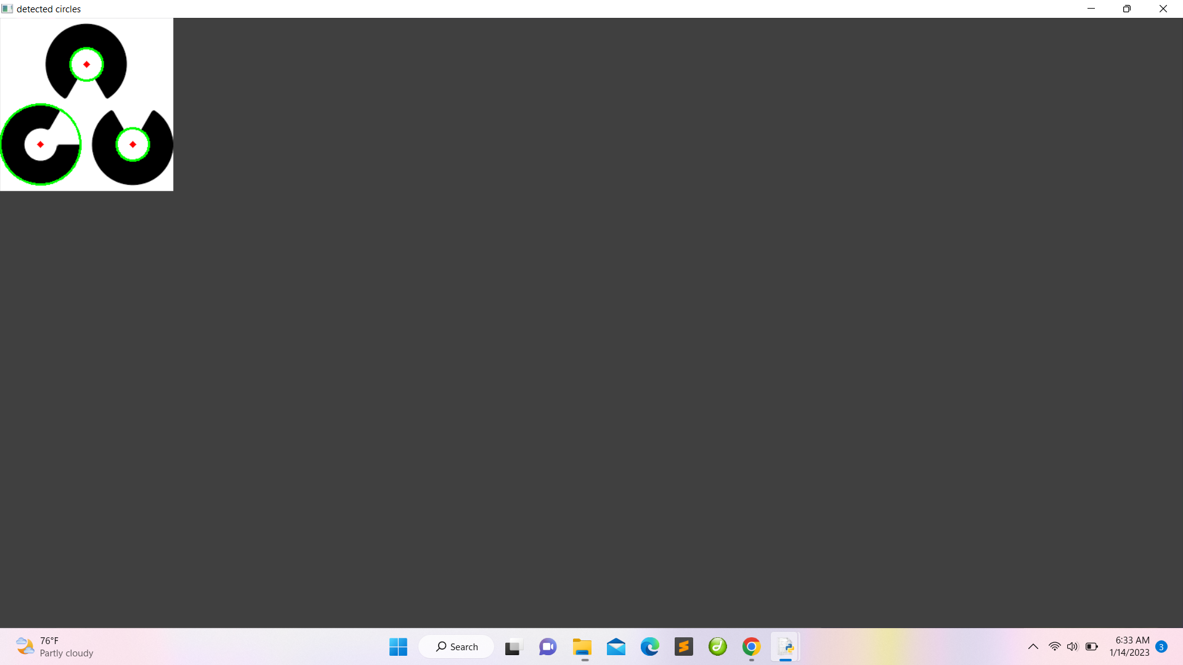

1. Grayscale

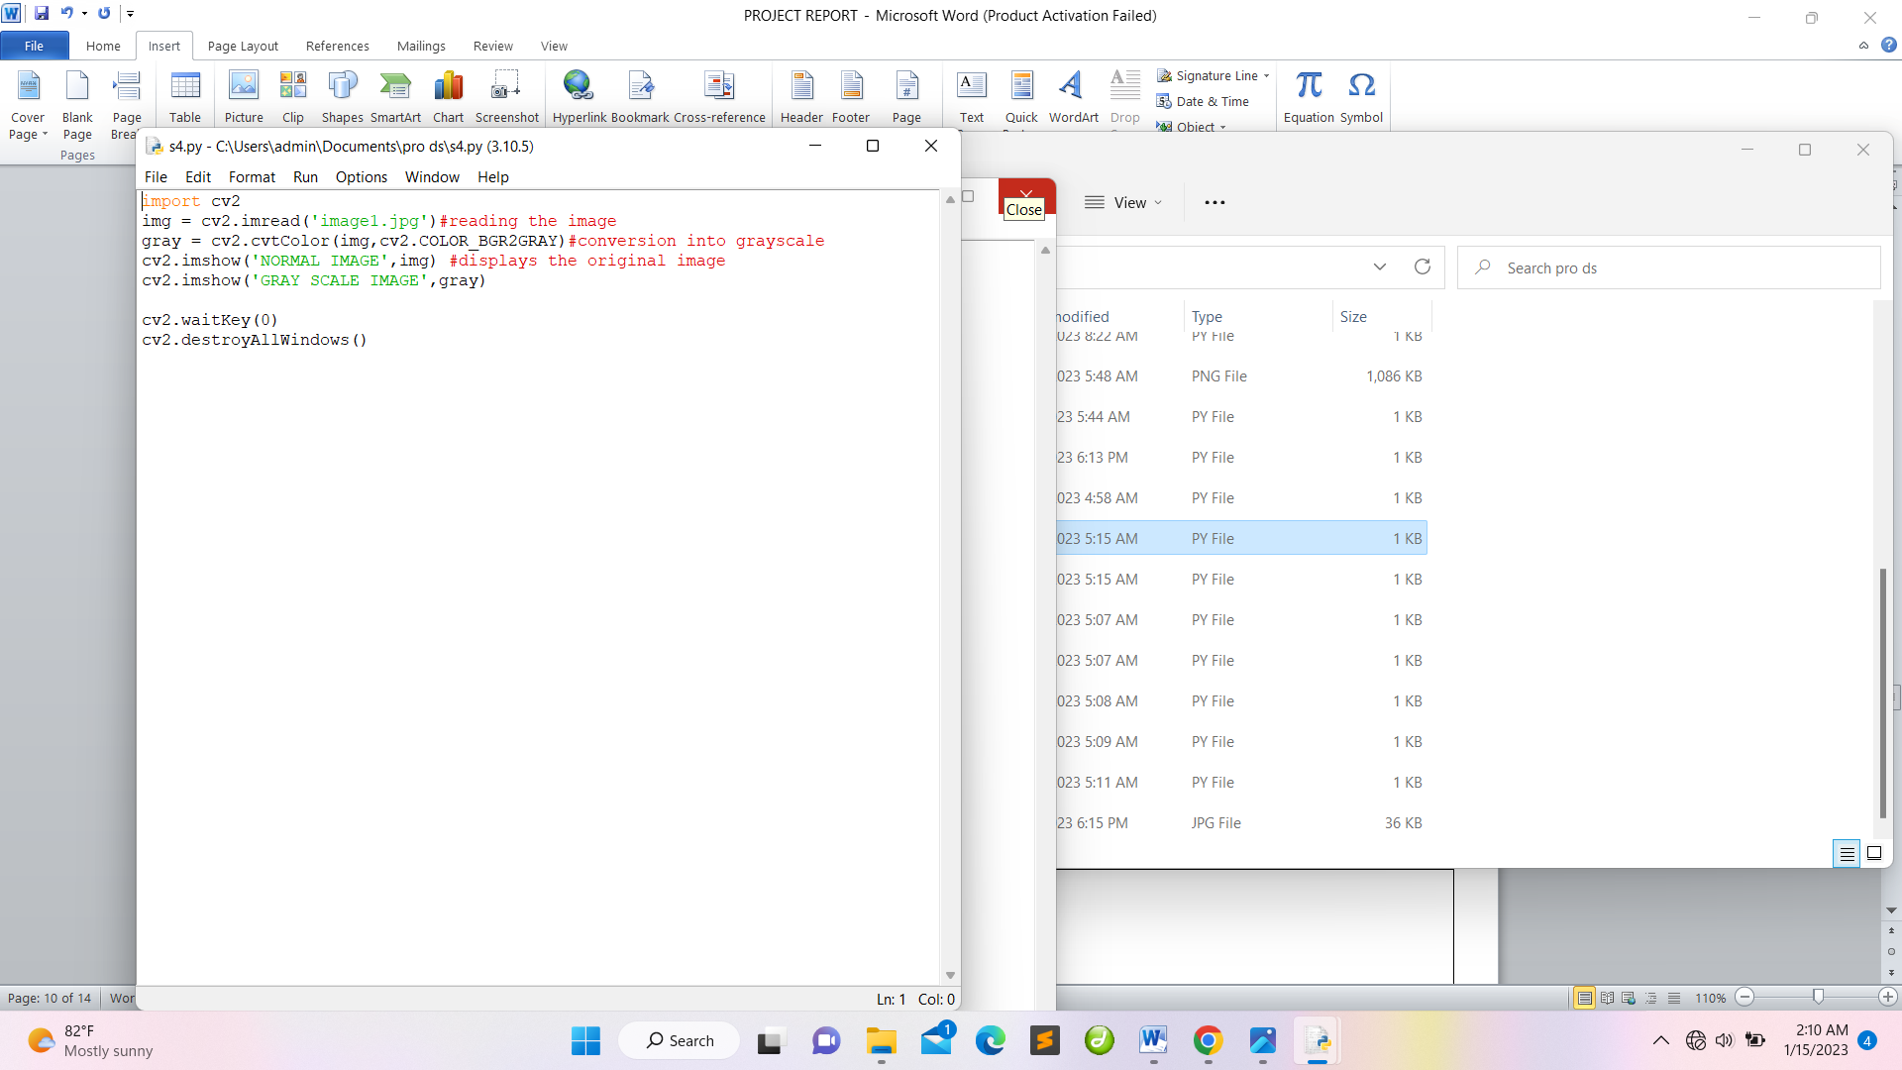

Output:

Normal Grayscale

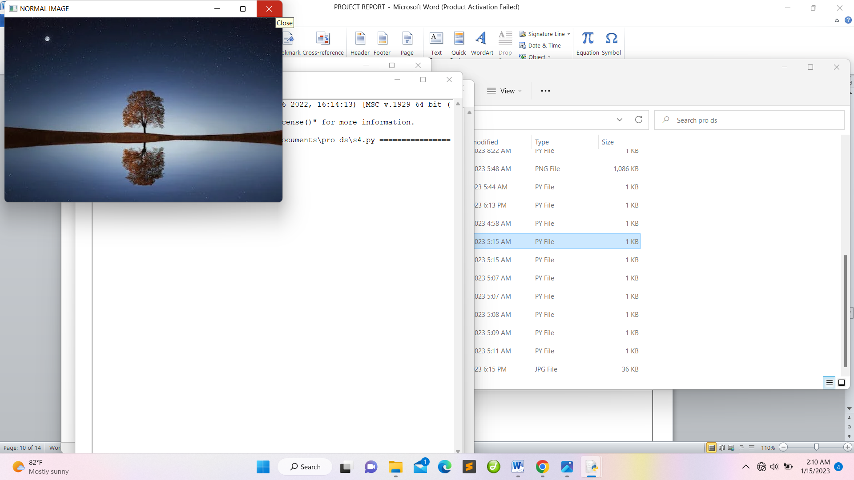 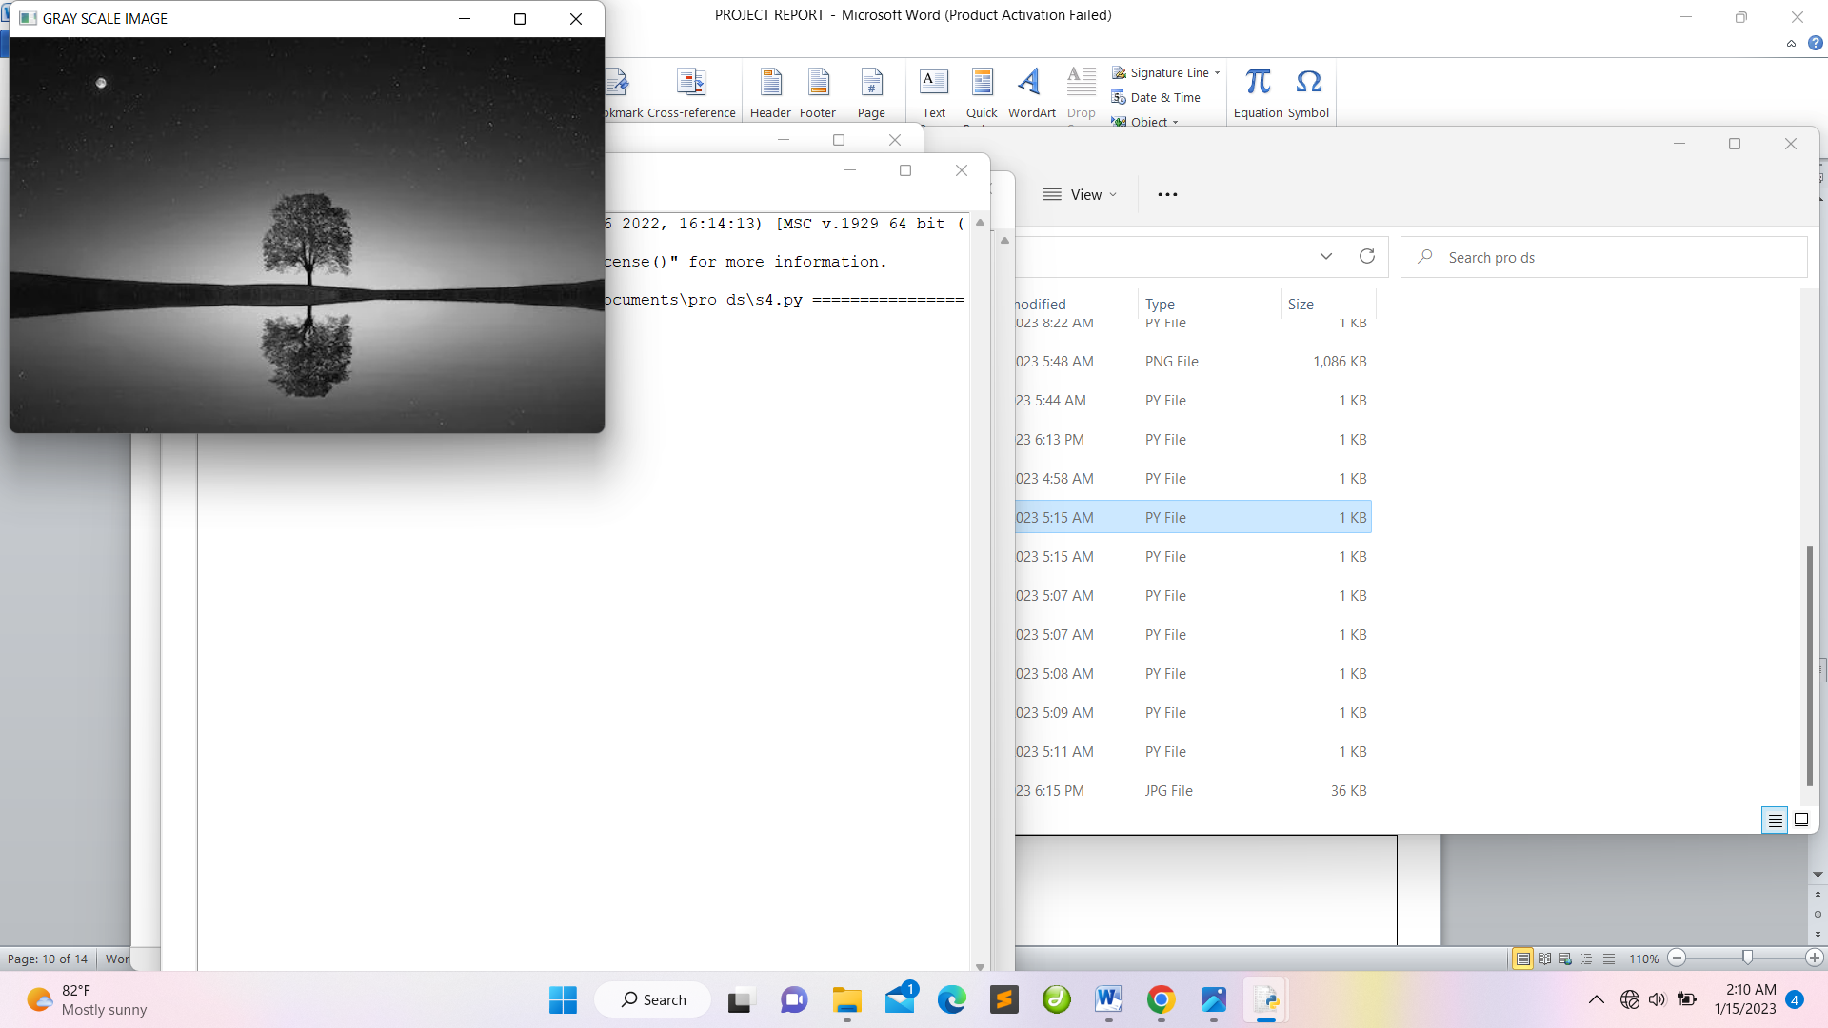

1. Splitting of image into diffrerent colour channels

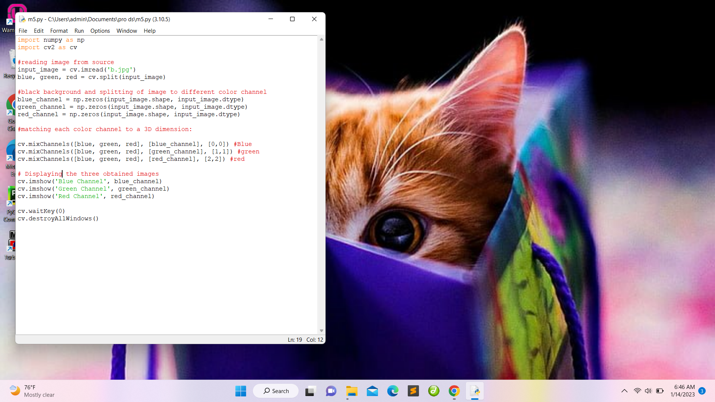

Output:

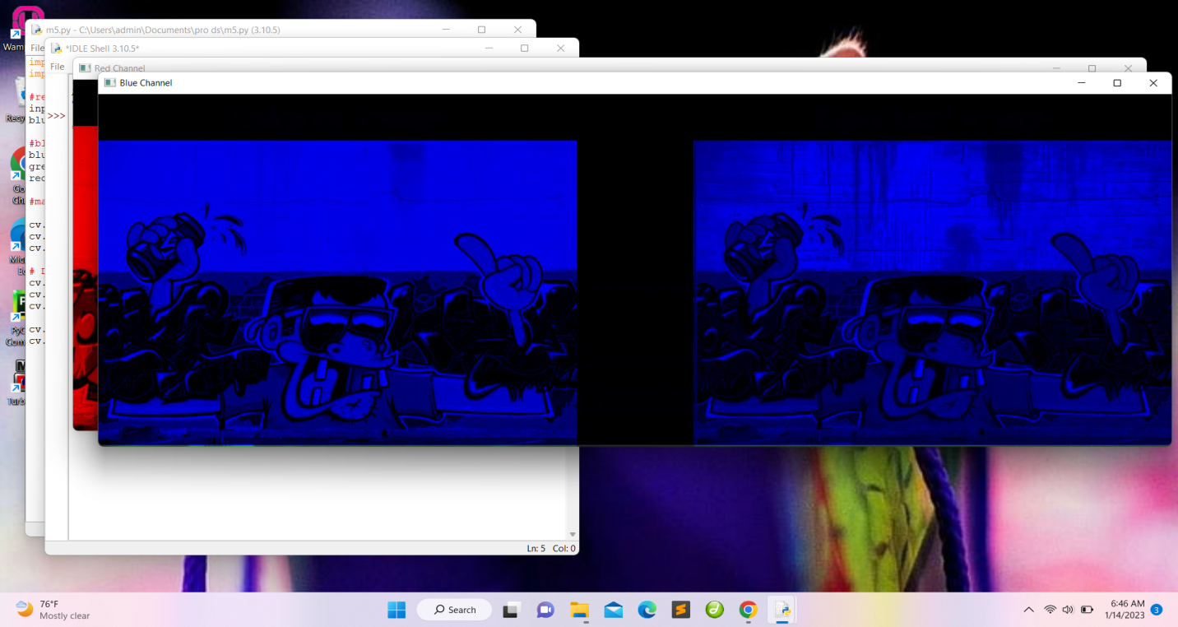 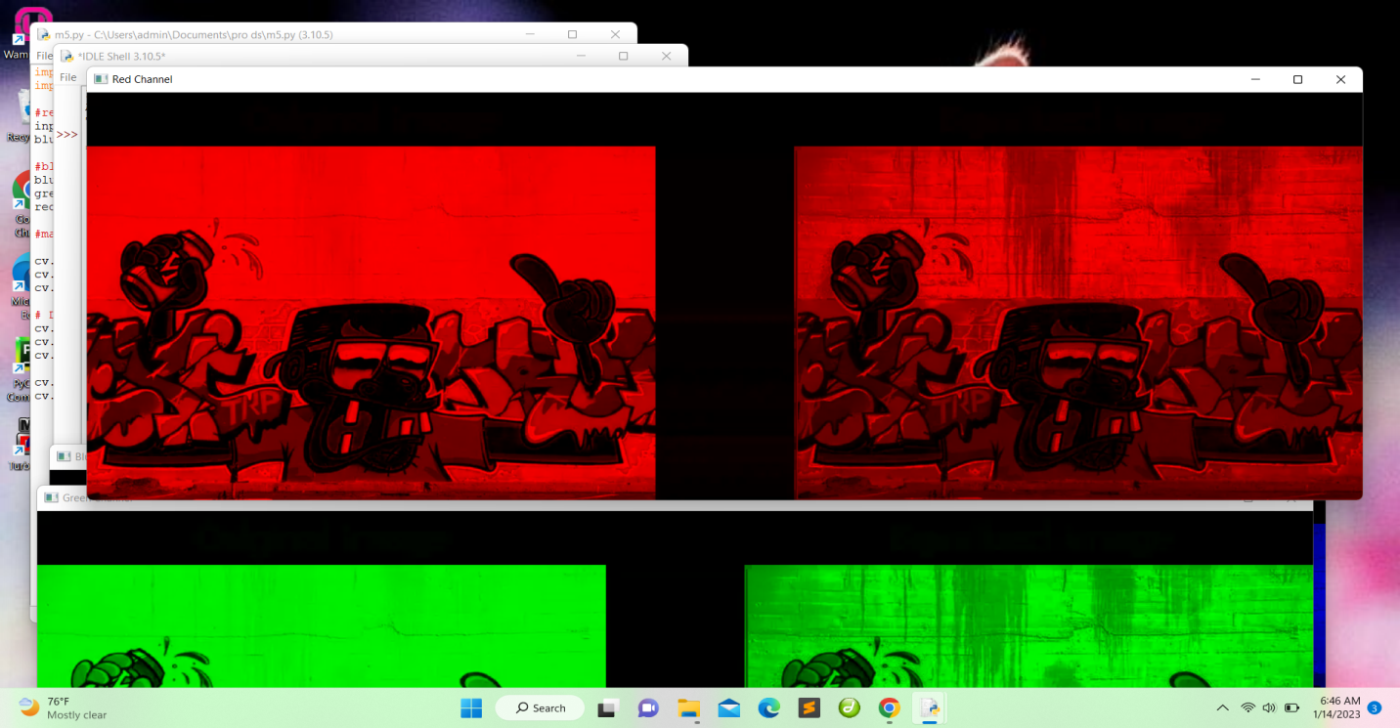

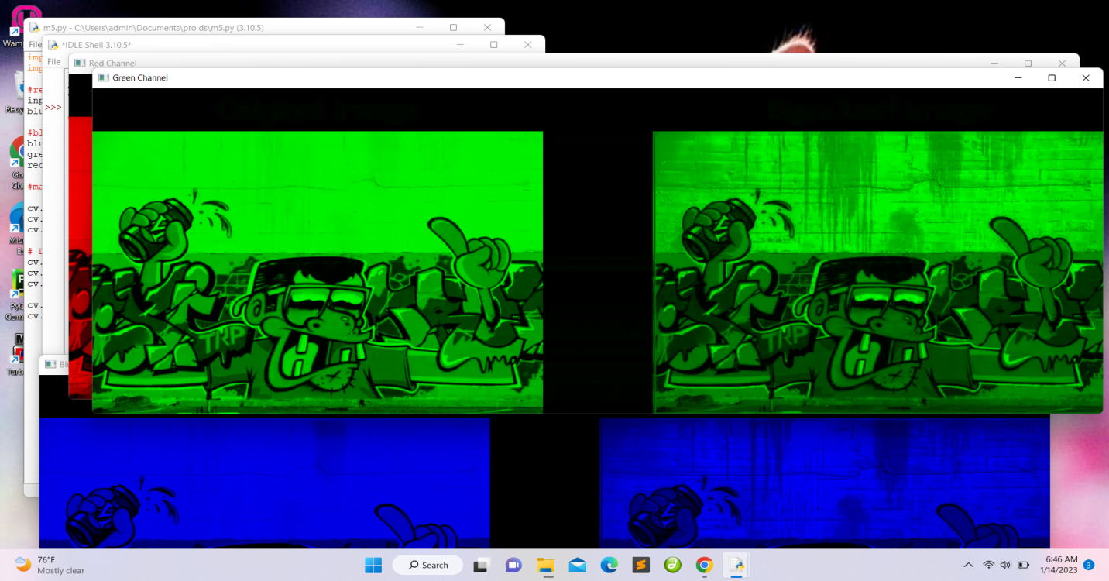

1. Flipping of the image

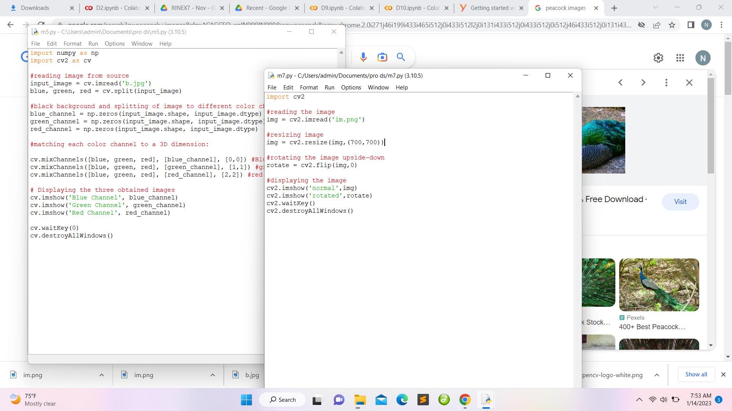

Output:

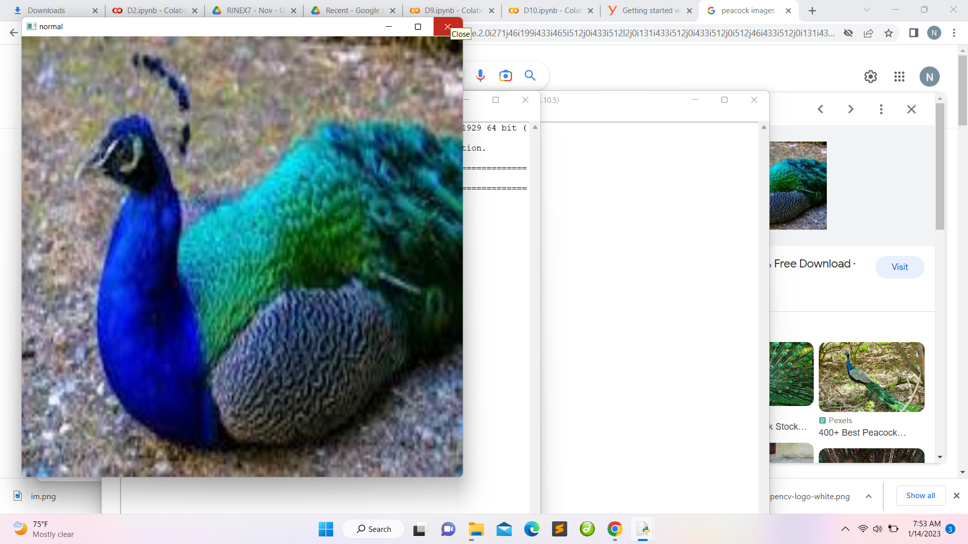 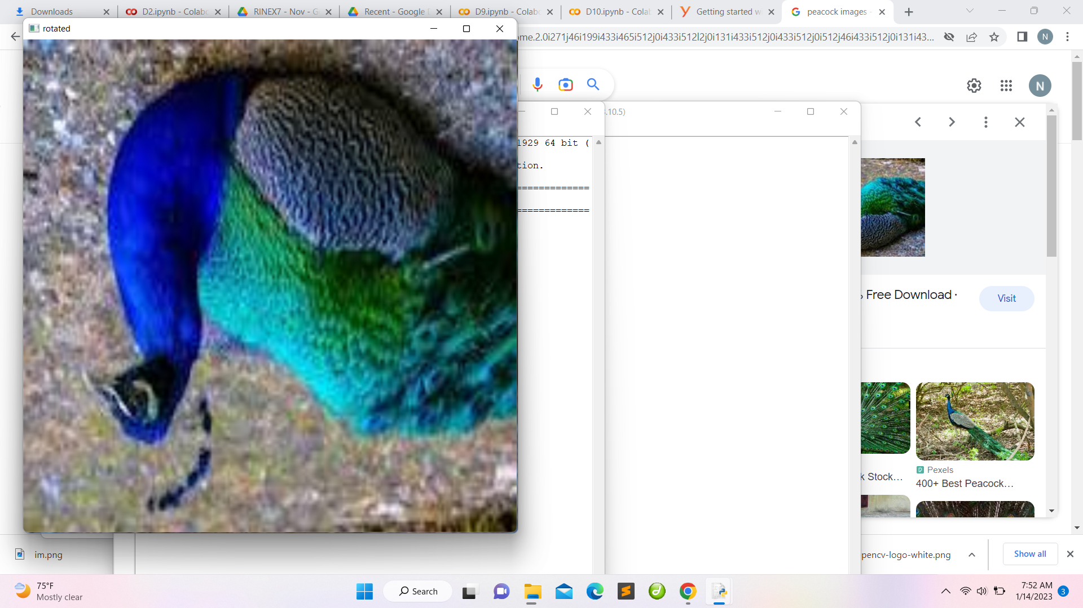

1. Reversing the color of the image

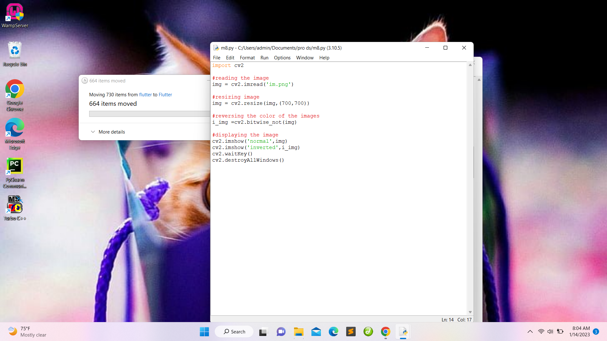

Output:

Normal Color reversed image

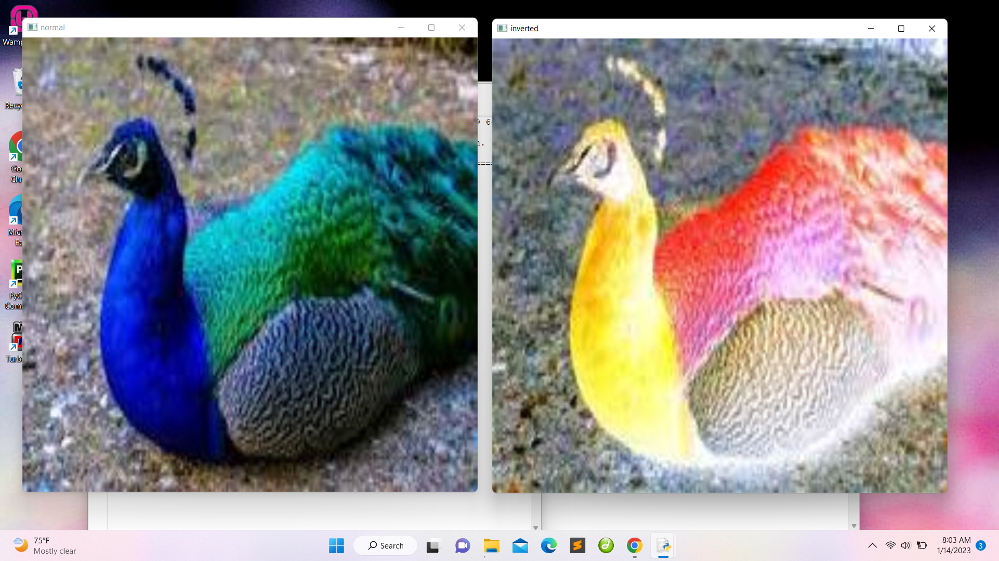 

1. Threshold

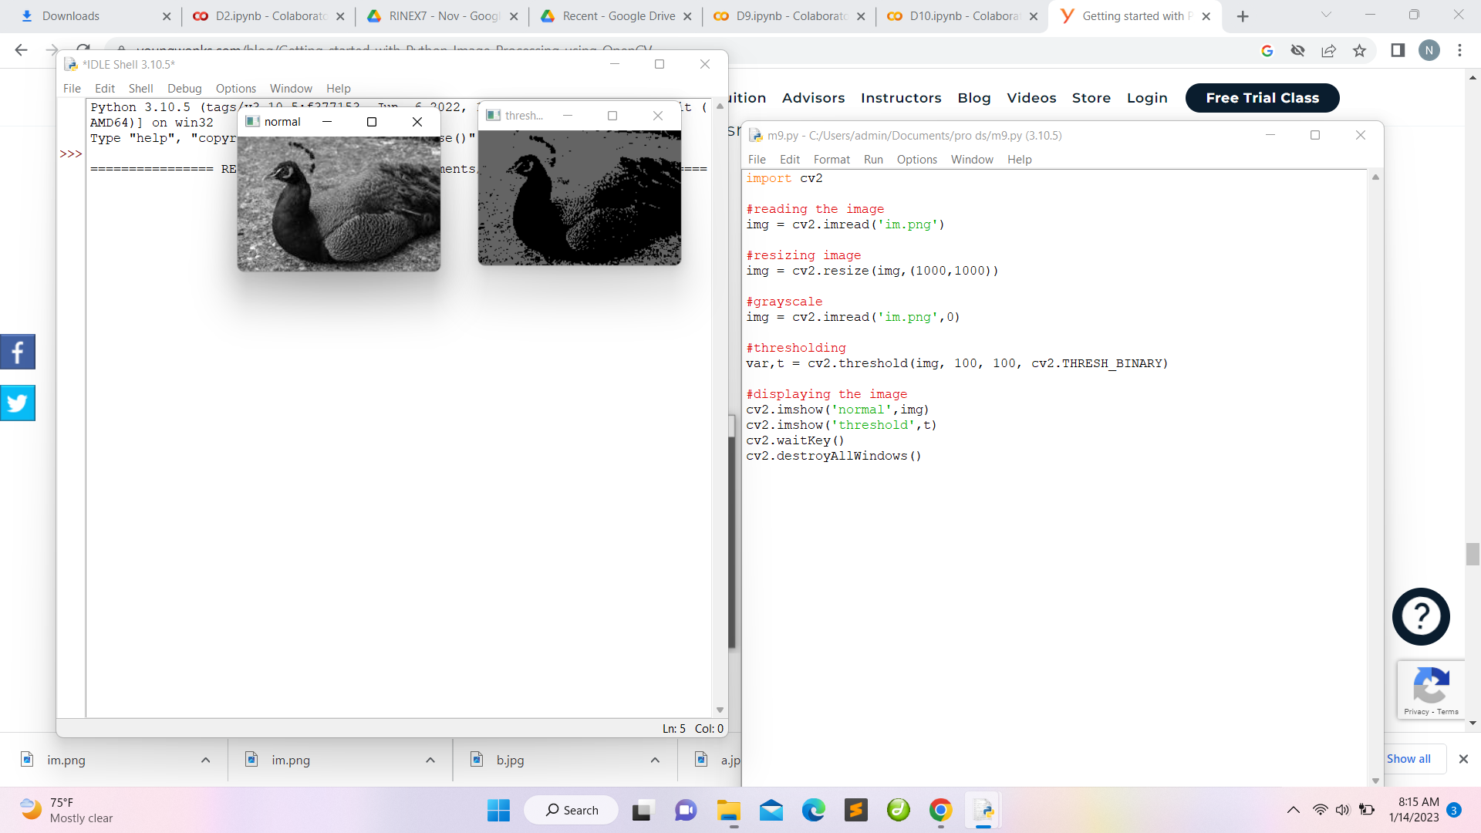

Output:

Normal Threshold

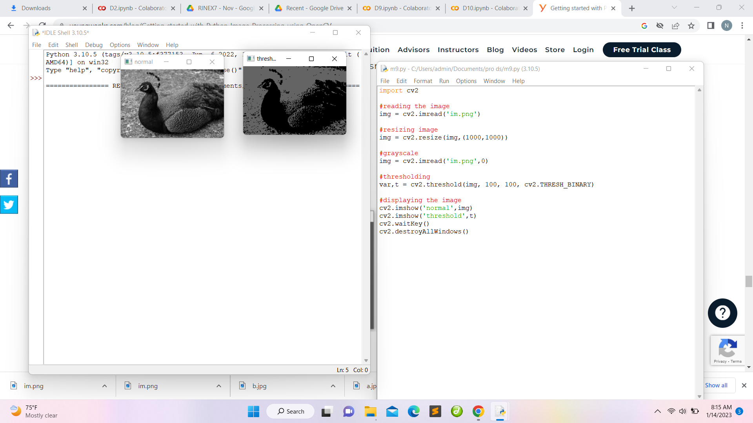 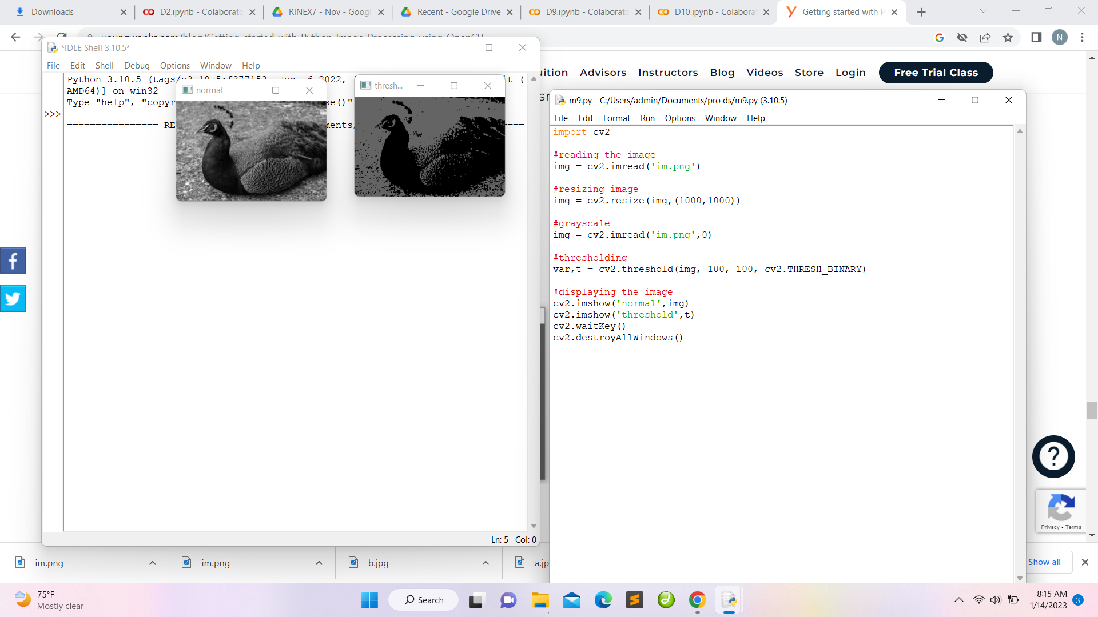

1. Detecting the edge of image

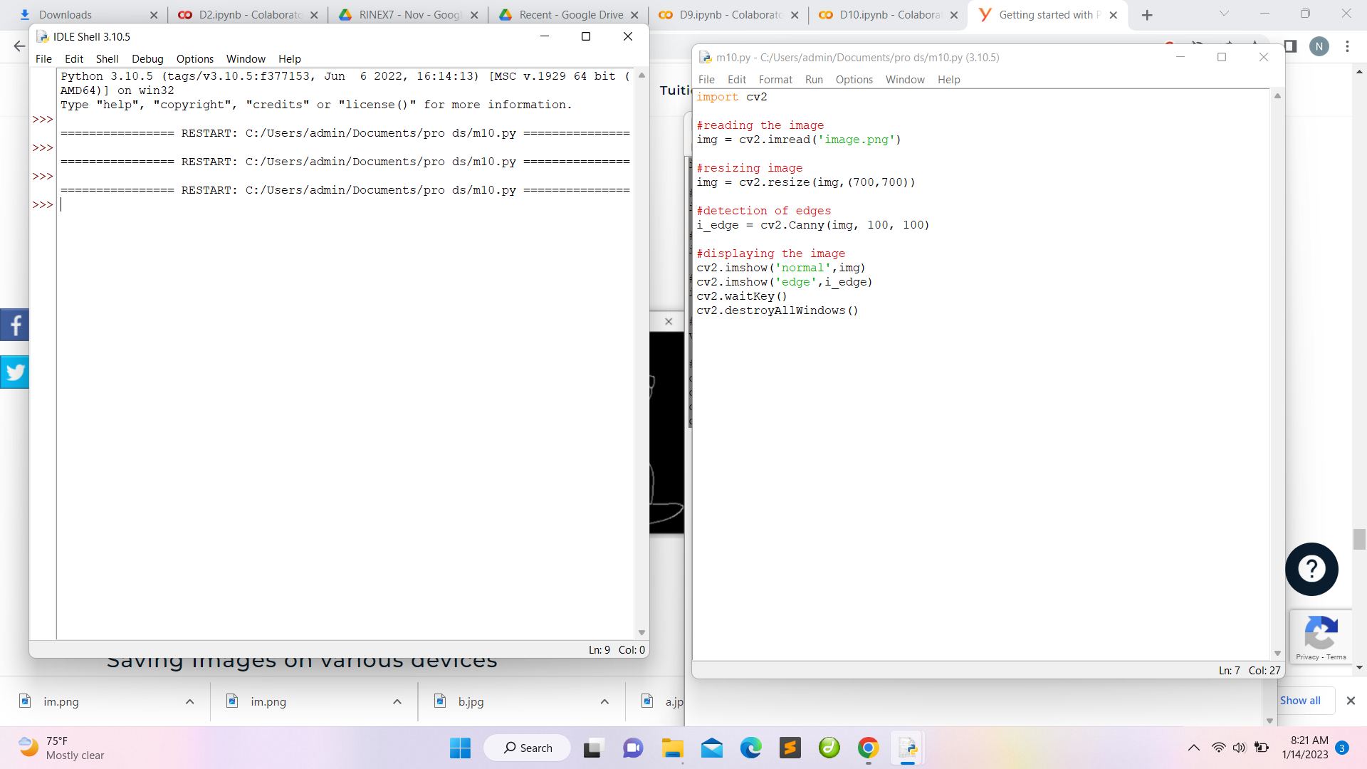

Output:

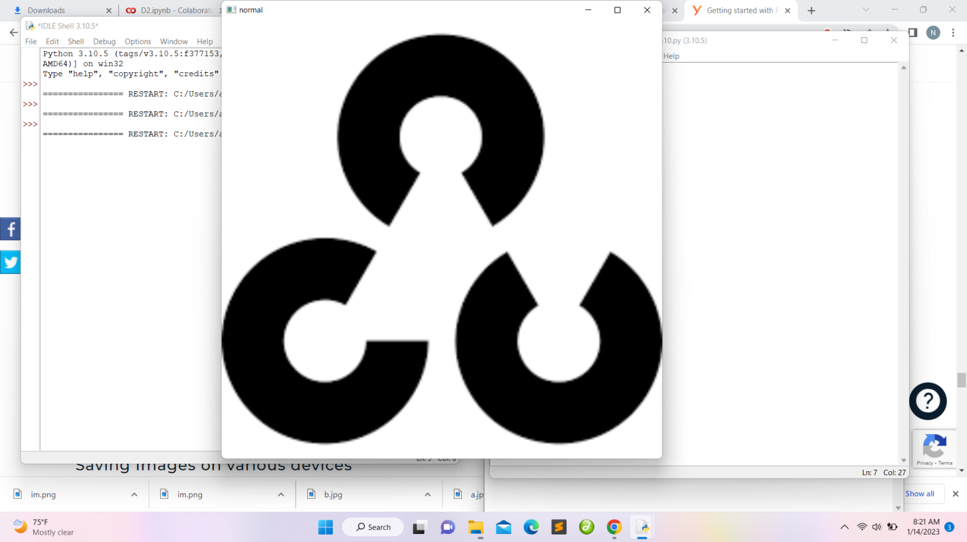 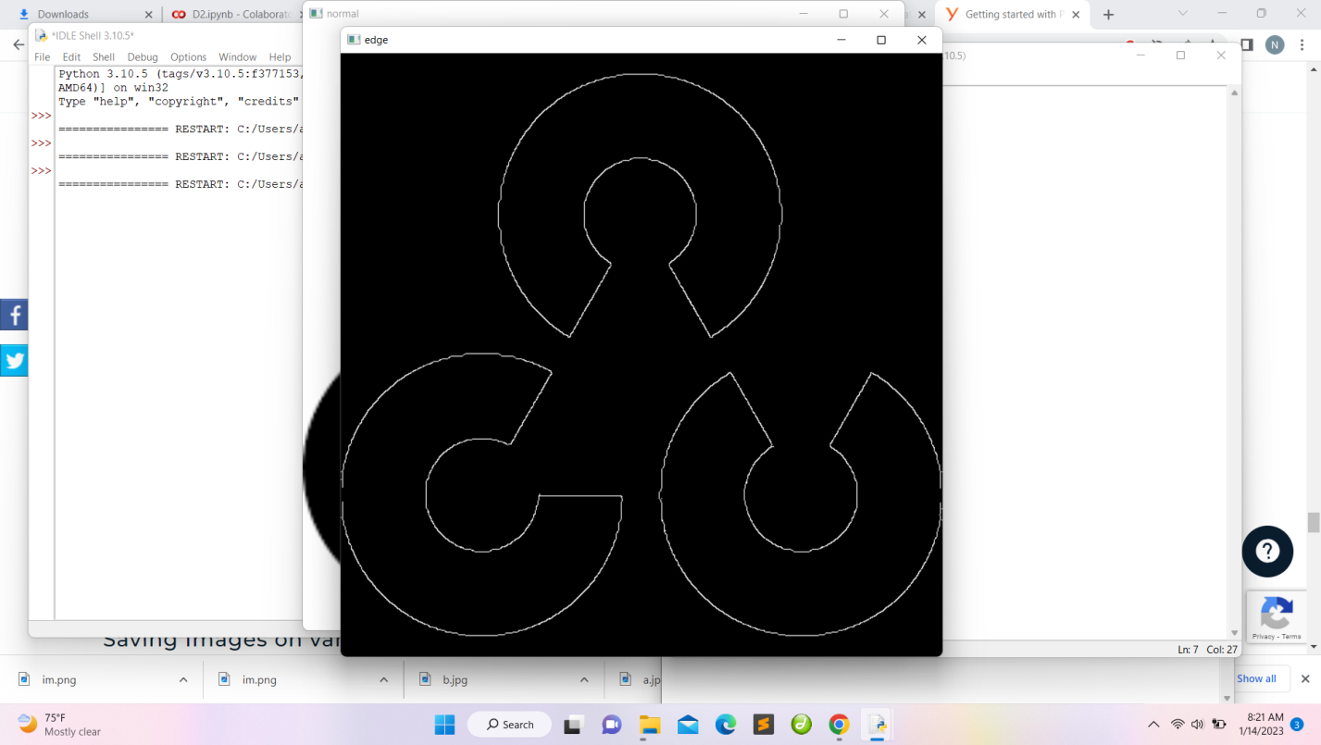

Links:

GitHub account: <https://github.com/Nivetha-Sree-M>

Link to drive: <https://tinyurl.com/rinexprojnivetha>

Repository Link: <https://github.com/Nivetha-Sree-M/Rinex-project>

THANK YOU